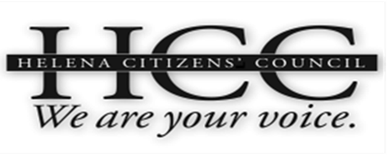 | HCC Meeting Agenda  July 22, 2015  City/County Building  Room 326  7:00 PM

7:00 PM: Call to Order / General Business
- Approval of June, 2015 Meeting Minutes
- Introduction of Guests
- HCC Coordinator Announcements
- Public Comment for items not on the agenda
7:05 PM: New Business/Jail
- Sheriff Leo Dutton??
- Public Comment
7:30 PM: Old Business: Water Conservation
- Group Discussion
- Public Comment
7:45 PM: Old Business, Transportation Plan
- Group Discussion
- Public Comment
8:00 PM: Old Business, Visioning
- Sumner Sharpe
- Public Comment
8:10 PM: Old Business, Sidewalk Priority Areas
- Group Discussion
- Public Comment
8:25 PM: New Business, HCC Protocol
- Group Discussion
- Public Comment
8:45 PM: New Business, Railroad Crossings
- Group Discussion
• Public Comment
8:50 PM: New Business, Schools
• Group Discussion
- Public Comment
8:55 PM: New Business, Confederacy Memorial
• Group Discussion
- Public Comment
9:00 PM: Adjourn

