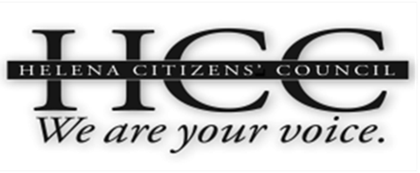 | HCC Meeting Agenda  April 22, 2015  City/County Building  Room 326, 7:00 PM

7:00 PM: Call to Order / General Business
• Approval of March, 2015 Meeting Minutes
• Introduction of Guests
• HCC Coordinator Announcements
7:05 PM: HATS (Helena Area Transit System)
- Steve Larson
- Public Comment
7:20 PM: Old Business: Outreach/Visioning Update
• Sumner Sharpe
- Public Comment
7:40 PM: Old Business: Quiet Zone
- Terry Ray
- Public Comment
7:50 PM: Old Business: Transportation Plan Update
- John Rundquist
8:05 PM: Old Business: Snow Removal
• ?
- Public Comment
8:20 PM: Old Business: Update on Resolutions
- Dick Sloan
- Public Comment
8:30 PM: New Business: Marketing/Advertising/ PR
- Group Discussion
- Public Comment
9:00 PM: Adjourn

